AIX – Extend filesystem

**DOCUMENT HISTORY**

|  |  |  |  |  |
| --- | --- | --- | --- | --- |
| Version | Date | Name | Version purpose | Status |
| 1.0 | 11/06/19 | Jonathan REY-GORREZ | Initial version | V |

Status: **W** = Writing in progress, **C** = for Comment, **A** = for **A**pproval, **V** = Validated, **O** = Obsolete

**DOCUMENT VALIDATION**

|  |  |  |  |
| --- | --- | --- | --- |
| Action | Date | Name | Role |
| Writing | 11/06/19 | Jonathan REY-GORREZ | Technical Referent |
| Control | 00/00/00 | Name | Role |
| Validation | 00/00/00 | Name | Role |

Table of content

1 FS extend 3

2 VG extend 4

# FS extend

Target is to get the filesystem back to 85% used.

The above isn’t true for *sapdata* filesystems.

Warning threshold is 98% so the target would be ~96%.

Identify the name of the Logical Volume, and the allocated/free space:



Based on the above, we should add 100GB to get back to 96%.

Identify the Volume Group:



Check the remaining space in the volume group:



If there is not enough space left in the VG, refer to next chapter “*2 – Volume group extension*” to add a new LUN.



If there is enough space available, extend the filesystem:



Double check that the filesystem is now below the threshold:



# VG extend

Things to note:

* Use a *SPARE* LUN instead of creating a new one.
* Standard LUN size is 300GB for application filesystems.
* Use the same naming convention for all LUNs.

Log in to the V7000 and go to *Pools > Volumes by Pool*:

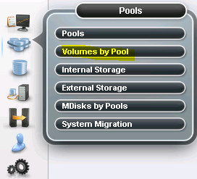

Scroll down to the LUNs mapped to the host we want to add a new LUN to identify the naming convention:



Right click and rename one of the *SPARE* LUNs:

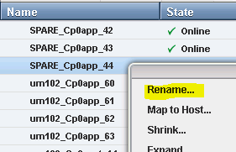

Match the same naming convention:

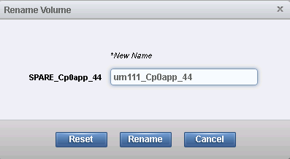

Right click the new LUN and map it to the host:

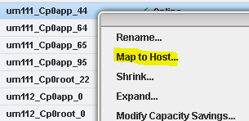

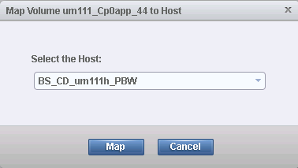

Now log in to the server, and run a scan to detect the new disk:



Identify the new disk name:



Add the new disk to the VG:



Double check that the disk has been added to the VG, and that the VG now has more space available:



